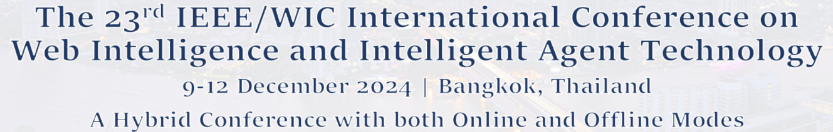
WI-IAT 2024 Workshop/Special Session Proposal Template
Heading
- Title of the workshop/special-session and acronym
- Proposed duration (half-day or full-day)
- Workshop/special session (co-)chair(s) name, affiliation and e-mail address
- Short CV of (co-)chair(s) including past experience in organizing workshops/special session and/or related events
Introduction
- Abstract: one paragraph describing the workshop/special-session purpose (max. 200 words)
- Scope and topics of the workshop/special session
Motivation and Rationale
- Why the workshop/special session is related to WI-IAT 2024
- Why the topic is timely and important
- Why the workshop/special session may attract a significant number of submissions of good quality
- Why the workshop/special session may attract a large number of attendees, in addition to the authors
- Why the workshop/special session differs from others
- Related workshops and conferences of similar topics
Workshop /Special Session Details
- Tentative committee lists (organizers, program committee, etc.)
- Expected number of participants and the expected number of submissions
- A short list of potential authors that are expected to submit papers to the workshop/special session
- A draft call for papers (max 1 page)
- A description of the publicity and promotion plan
- Workshop/special session format planned (keynote, expected number of presented papers, invited talks, panels, demonstrations, etc.)

Tentative Internal and External Schedule (Except adjustments by the Chairs to align all workshop/special session schedules)
- Submission deadline
- Review deadline
- Acceptance deadline
- Camera ready
- Program ready

